## Prelim Pages

Version Control /Approval

## Introduction

Operational Description is a high level description of the spreadsheets operation and processes. Familiarity with this content enhances the ability to use the sheet and prepares a maintainers knowledge prior reading the Technical Manuals.

## Definitions

|  |  |
| --- | --- |
| **Term** | **Meaning** |
| Data Set | Refers to one or more sheets in the master spreadsheet. They are grouped based on the value in the exeID column row 2. |
| Organisational Structures | The HR term for the hierarchical linking of objects representing departments and internal groups or team and positions within them. |
| Test Tool | The automation test tool used to execute scripts using the data from the master spreadsheet |
| Test Results | Refers to an output from the test tool in Excel format for retrieval from the results folder. More specifically aimed at Quick Test Pro |
| Import | The process of retrieving data from the test results. |
| Export | The process of sending a specific data set to either the test tool for execution or to the test teams (formatted or raw) |
| Restructure | The process of rearranging, adding or removing columns in all the data sets simultaneously |
| Data Generation | The process of generating new data or updating existing data in the master spreadsheet. |
| Target System | Generic reference to the system the scripts are to execute against. In the case of SAP, the server, ID and client are part of the target system identification. |

## Automated Tasks

The sheet contains a range of macros or programs that automate the task of generating and managing data for the test tool to utilise. Automated tasks are:

* Creating user defined Organizational Structures.
* Generate new data from the user defined Organizational structure.
* Exporting specific datasets to the test tool.
* Importing completed (or partially completed) test results.
* Exporting to the testers in a custom format (program controlled).
* Exporting to the test teams without custom formatting.
* Preparing data for reuse in a new target system.
* Restructure the data columns to fit the order of operations.

## Organizational Structures

Organizational (Org) structures in SAP[1] (and similar systems) define: supervisory roles, reporting chain, HR Management, Pay, Credit Card and other aspects of employment in an organisation. Correctly building structures is pivotal to the operational testing of several aspects of the system, including security or roles.

Org structures consist specifically of an Org Unit[2] and Positions[3] in a hierarchical map. Structures and their data also define workflows[4] that are triggered when certain user actions meet defined criteria. See Figure 1 – Sample Hierarchical Chart below.



Figure – Sample Hierarchical Chart

The spreadsheet emulates the familiar hierarchical chart using a tree view and provides users with the ability to define the structure and some base data for the data set. When using the tool, the user is guided by dialogs that collect data and store for later use.

Users may optionally add or hire people into positions they add. A design limitation is there can only be one “root” from which the structure hangs. In Figure 2 below, the “org” at the top left is the root node of the tree.

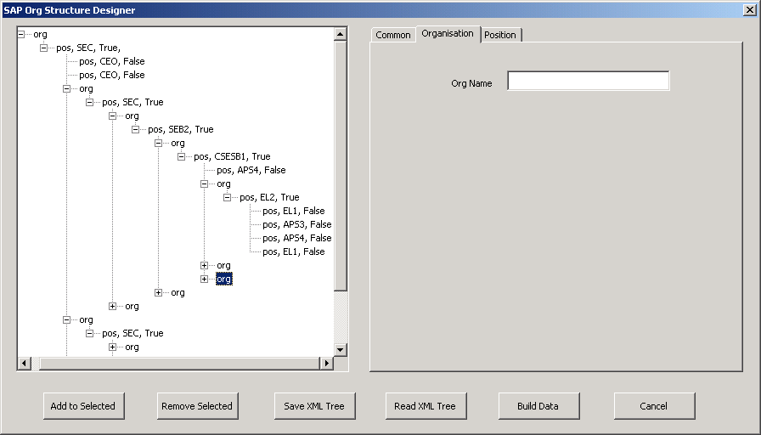

Figure

Focus on the structure simplifies data collection requirements. Generation brings the structure and data together for further manipulation by the users.

## New Data Generation

The user defined structures are used in conjunction with user defined defaults[5] to generate new data sets for execution. Data generation lays all the necessary basic data for Org Units, Positions and Hiring people into a new spreadsheet. Modification may optionally be applied post generation for a few exceptions[6] to the initial data.

Special data, such as AGS[7] (Personnel Number), Date of Birth, names, gender, addresses are automatically created by either using an internal programmed generator, sequential list or random value or random list selection.

## Exporting to test tool

Exporting a data set to the test tool takes the prepared data set (and may have more than one sheet in the data set) and copies the data verbatim across to a format suitable for the test tool. Specifically the sheet is in Excel 97-2003 format. Data with leading zeros are not altered by the process in either direction.

## Importing test results

Test results are imported from the test tools run-time[8] results folder. Data is retrieved by locating the run-time results and selecting the result folder in a dialog. This starts a verbatim copy from the run-time results back to the spreadsheet. Modifications made to the run-time data table are made available for analysis, further use in another execution and/or for the test teams.

## Exporting to test teams

Most test teams do not require the detailed data used by the test tool. To facilitate this output, the data is exported out into a more familiar and friendly format or may be exported raw for greater details if the test teams require them. The solution blends a user created header with data set information to give a formatted output.

## Preparing data for reuse in a new system

Existing data preparation cleans up the SAP data and enables re-use on a new system. The resource savings are significant and provide early execution start up. The automation takes care of specific details when executed on a data set.

## Restructuring Data Columns

The ability to re-structure the columns is part of essential maintenance with the data set. Over time, the need for new and removal of redundant columns. With the need to expand the scripts to hire a wider range of staff the sheets have required additional data[9]. The process moves all the data into a single temporary resource while the re-structure is done. Two caveats apply with this feature:

* The dataset is shared with PST and other parts of Automation, and requires prior agreement before implementing a change.
* The restructure should not be carried out while execution using any data set is in progress. Wait till the execution is finished and the results collected before the restructure.

...oooOOOooo...

1. SAP is a specific target system in this instance.
2. Organizational Units in Human Resource Management (HRM) systems are a Department, Division or team within the organization.
3. Positions define a place in a structure independent of the actual employee; this is a target system design choice which augments flexibility with temporary assignments, promotions and employee churn.
4. Workflows are an internal action that sends a notification to the appropriate area under specified conditions.
5. Defaults are managed by using a special sheet to provide a way to pre-define data and control overriding of existing data. The user has considerable control at their disposal when this is utilised.
6. Sometimes different codes are required due to internal needs of the HR or Pay sections. E.g Hiring a Part Time on an AWA in Human Services uses a special code on Infotype 0008 when compared to Centrelink.
7. AGS numbers are sequentially generated on demand, using a weighted sum modulus 11 calculation. See XXX document for more details.
8. Terminology may vary from tool to tool. A run-time result is the location of the post execution output.
9. The range of staff hires include full time, part time, contractors, AWA, Medical Officers, casual and non-ongoing. This impacts on a number of points in the dataset.